**SMB Assessment**

**Objective:**

* Install and configure Samba for file sharing.
* Define shared folders with appropriate permissions.
* Enable anonymous access and verify connectivity.

**Install Samba Packages - Installs the required Samba packages (samba, samba-common, and samba-client) for file sharing.**

**yum install samba samba-common samba-client -y**

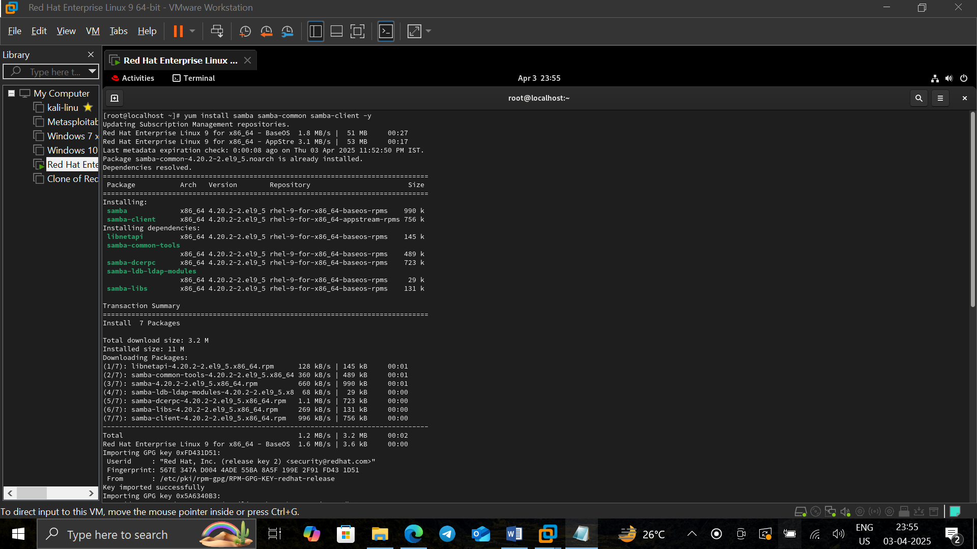

**cp /etc/samba/smb.conf smb.conf.default** - Creates a backup of the default Samba configuration file.

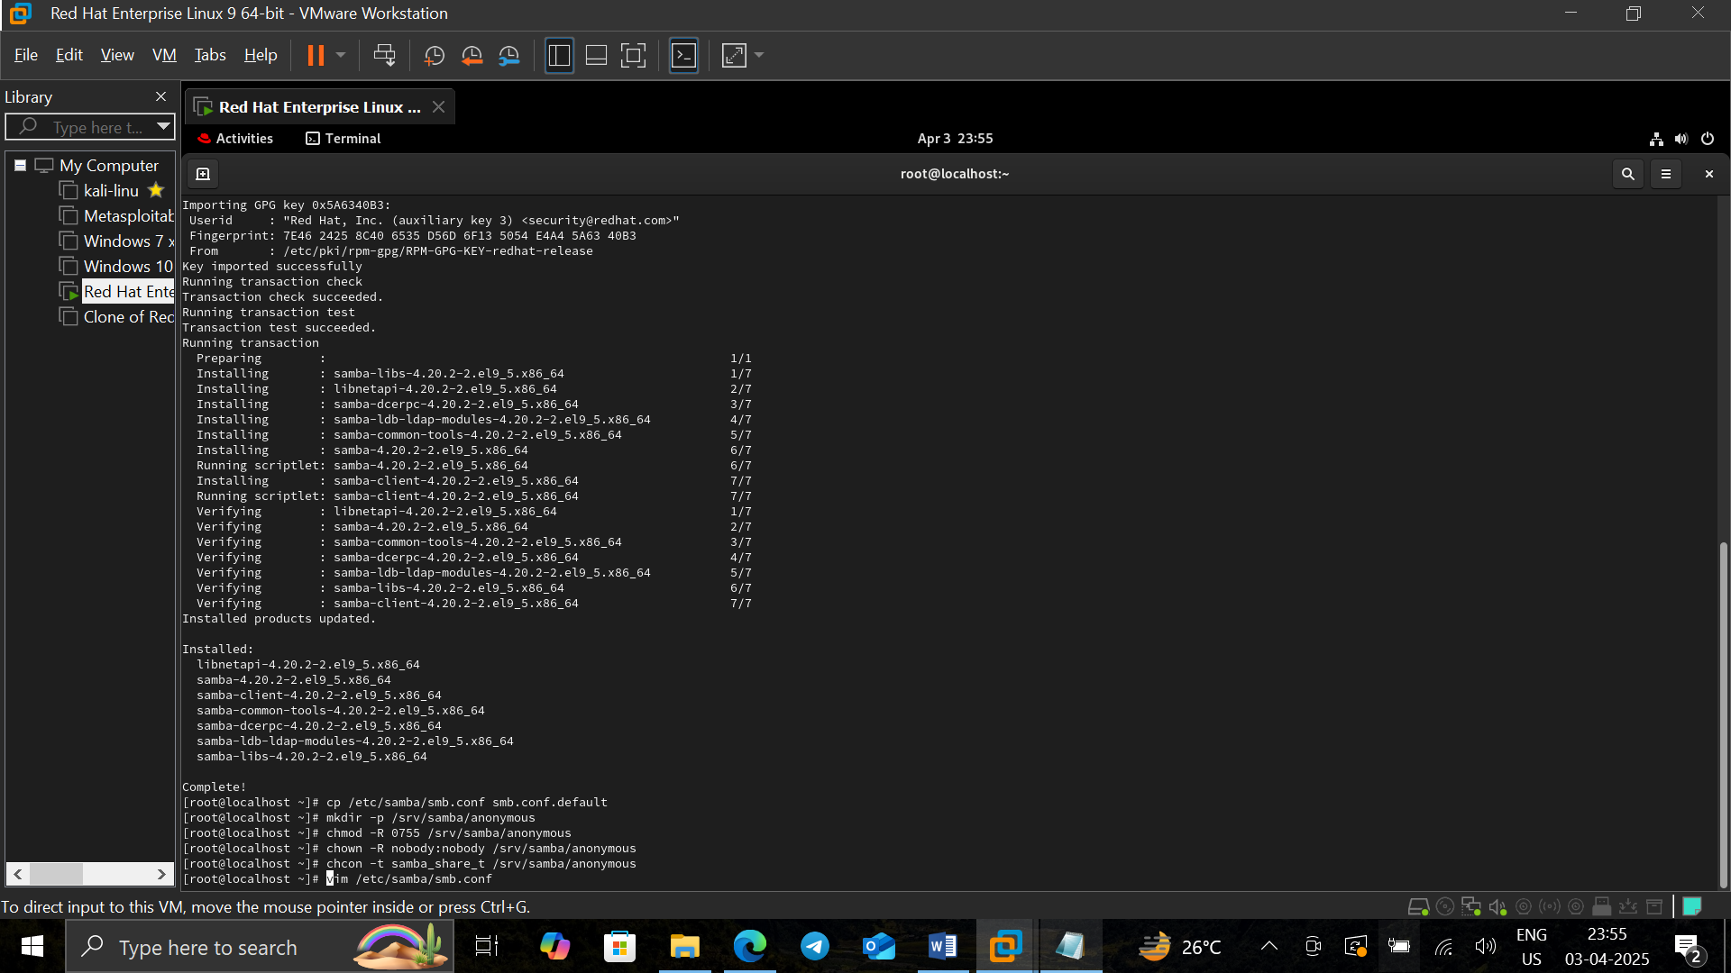

**mkdir -p /srv/samba/anonymous** - Creates a directory for anonymous file sharing.



chmod 0755 **gives read & execute permissions to others.**



chown nobody:nobody **assigns ownership to the** nobody **user**.

chcon -t samba_share_t **assigns the correct** SELinux **security context.**



**vim /etc/samba/smb.conf** - Opens the Samba configuration file to define the shared folder settings. 

**Configuration:**

[global] - workgroup = WORKGROUP ,server string = Samba Server %v, netbios name = rhel9,security = user, map to guest = bad user, dns proxy = no

[Anonymous] - path = /srv/samba/anonymous, browsable =yes, writable = yes, guest ok = yes, read only = no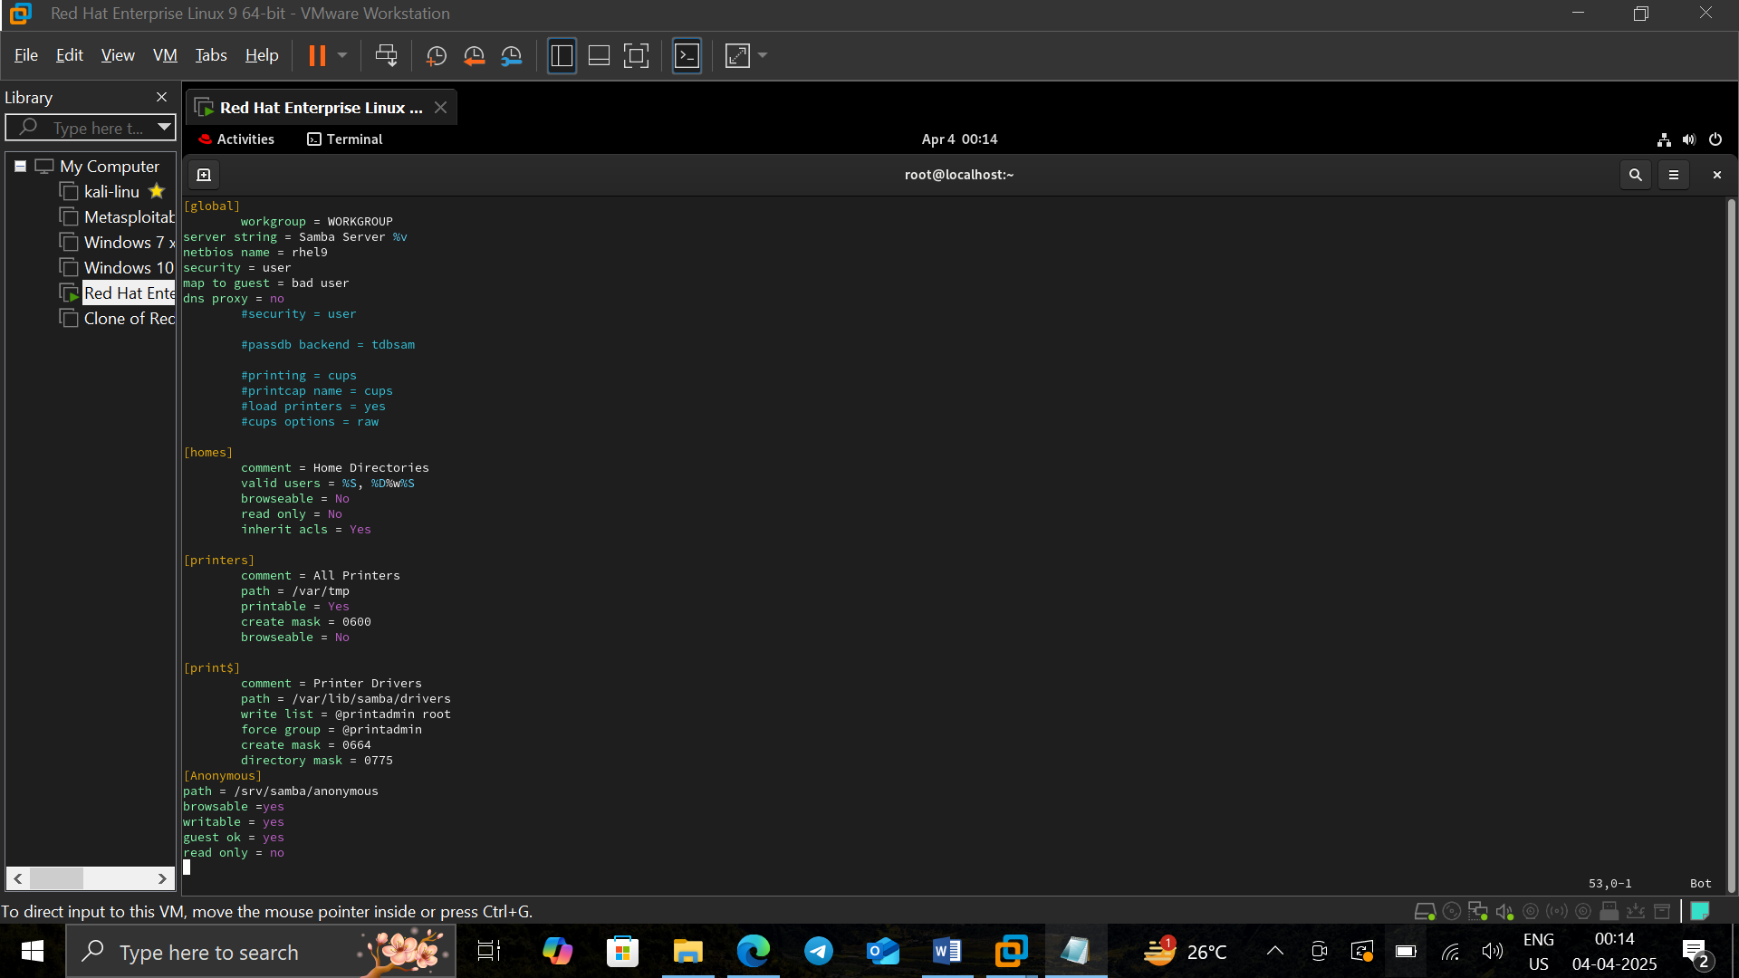

**Testparm -** Checks for syntax errors in the Samba configuration.

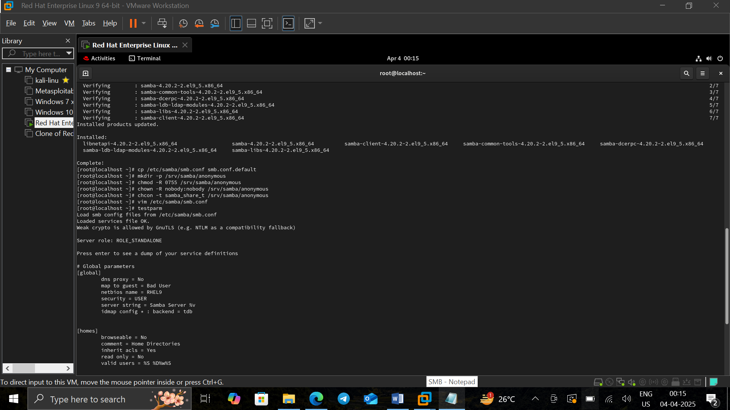

**firewall-cmd --permanent --add-service=samba -** Allows Samba traffic through the firewall.

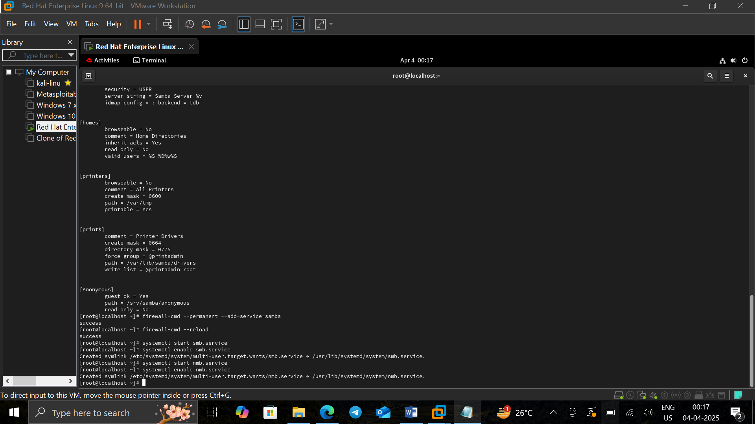

**firewall-cmd –reload - **

**Starts and enables the** smb **(Samba) and** nmb **(NetBIOS) services.**

**systemctl start smb.service -**



**systemctl enable smb.service**

**systemctl start nmb.service**



**systemctl enable nmb.service**

**Win + r -------\\rhel9(server ip) -** Connects to the Samba share from a Windows machine.

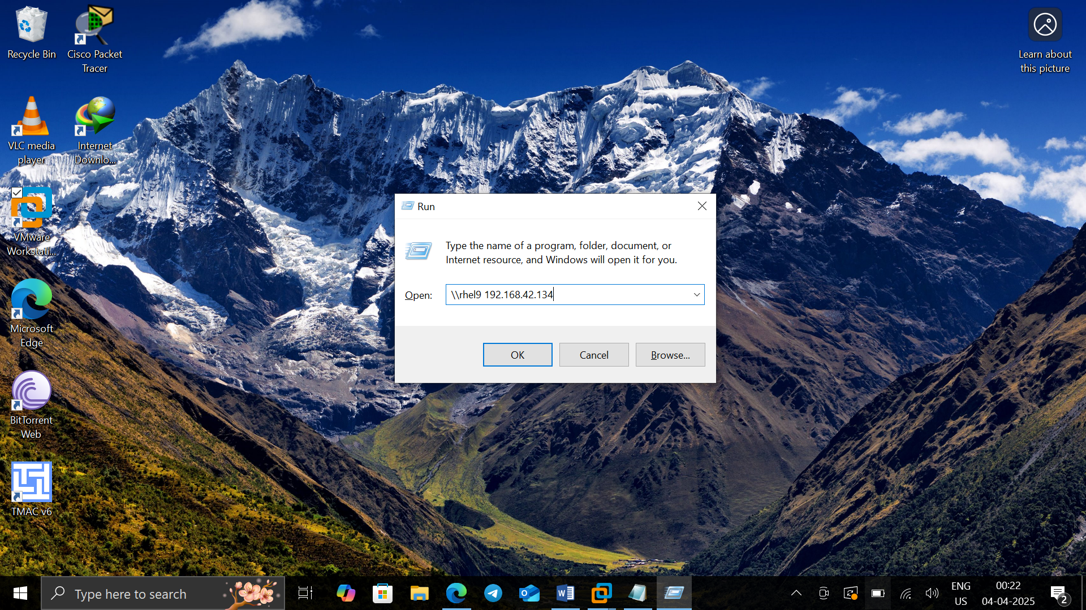

**Anonymous access -** Ensures that the shared folder is accessible without authentication.

